**Q1– Write down the column names of the test case format.**

1 – TC.NO

2 – Actor

3 – Module

4 – URL

5 – Test case description

6 – Steps

7 – Test data

8 – Actual result

9 – Expected result

10 – Pass/Fail

11 - Remark/comments

12 - Creation date

13 - Created by

14 - Verified by

15 - Verified date

**Q2 – Write down the column names of the Bug Id format.**

1 - Bug Id

2 - Actor

3 – Module name

4 – URL

5 – Steps

6 – Test data

7 – OS

8 – Browser

9 – Resolution wise

10 – Expected result

11 – Status

12 – Assignee

13 – Bug Priority

14 - Remark/comments

15 - Creation date

16 - Created by

17 - Verified by

18 - Verified date

**Q3 – Write down test cases for Register form in Shope-clues.**

**Test cases for Register form**

1. Verify when click on Register link
2. Verify design of registration form in multiple form in multiple OS and browsers
3. Verify when Internet data is ON
4. Verify when Internet data is OFF
5. Verify when user clicks multiple times on Register button
6. Verify when enter numeric value in Email-ID
7. Verify when enter alphanumeric value in Email-ID
8. Verify when enter single character/single alphabet in Email-ID
9. Verify when enter special/junk character in Email-ID
10. Verify when enter trimmed Email-ID
11. Verify when enter Email-ID having different domain
12. Verify when enter already existing Email-ID and Mobile No.
13. Verify when enter blank Email-ID and Mobile No.
14. Verify when enter valid Email-ID and Mobile No.
15. Verify the minimum and maximum length of Email-ID and Mobile No.
16. Verify when enter Invalid Email-ID and valid Mobile No.
17. Verify when enter blank Email-ID and valid Mobile No.
18. Verify when enter blank Email-ID and Invalid Mobile No.
19. Verify when enter Invalid Email-ID and blank Mobile No.
20. Verify when enter valid Email-ID and blank Mobile No.
21. Verify when enter valid Email-ID and Invalid Mobile No.
22. Verify when click on Register and Password Checkbox
23. Verify when Checkbox is Unchecked
24. Verify when user clicks multiple times on checkbox
25. Verify when enter Invalid Password
26. Verify when enter Valid Password
27. Verify when enter blank password
28. Verify when both the Email and Mobile No. field are blank and click on checkbox
29. Verify when minimum/maximum length of Password
30. Verify when user clicks multiple times on Register option
31. Verify the Hyperlinks are properly working or not
32. Verify when user clicks multiple times on Hyperlinks
33. Verify when all the details are blank and click on register button
34. Verify when all the details are Invalid and click on register button
35. Verify when user directly click on Login link without filling the details in register form

**Test cases for Login form**

1. Verify when click on Register link
2. Verify design of registration form in multiple form in multiple OS and browsers
3. Verify when Internet data is ON
4. Verify when Internet data is OFF
5. Verify when user clicks multiple times on Register button
6. Verify when enter blank Mobile No.
7. Verify when enter Invalid Mobile No.
8. Verify when enter valid Mobile No.
9. Verify when enter numeric value in Email-ID
10. Verify when enter alphanumeric value in Email-ID
11. Verify when enter single character/single alphabet in Email-ID
12. Verify when enter special/junk character in Email-ID
13. Verify when enter trimmed Email-ID
14. Verify when enter Email-ID having different domain
15. Verify when enter already existing Email-ID or Mobile No.
16. Verify minimum/maximum size of Email-ID or Mobile No.
17. Verify when user clicks multiple times on Login Via OTP Button
18. Verify when user trying to enter Email-ID and Mobile No. at the same time

**Q4. Create a bug report for Sign In page in Kuber Industries application.**

**Name – Ashwini Patil**

**Device – OPPO F1s**

**Android version – 5.1**

**APK Version – 3.2**

**Bug-ID 1**

**Module Name –** Sign up

**Bug description –** Page is fixed for the device.

**Bug image:**

**Bug-ID 2**

**Module Name –** Sign up

**Bug description –** When user enter Invalid details and click on Sign Up button it will not display validation message for all the fields.

**Expected result –** System should fire validation message for all the fields.

**Bug image:**

**Bug-ID 3**

**Module Name –** Sign up

**Bug description –** Maximum length is accessible for Mobile No.

**Test data-** Mobile No.- “123456789012”

**Expected result –** System should check the minimum/maximum length of Mobile No.

**Bug image:**

**Bug-ID 4**

**Module Name –** Sign up

**Bug description –** Numeric value accepted in Name field

**Test data-** First name – “123”

Last name – “123”

**Expected result –** System should fire validation for Invalid First name and Last name.

**Bug image:**

**Bug-ID 5**

**Module Name –** Sign up

**Bug description –** Numeric value accepted in City field.

**Test data –** City name – “12345”

**Expected result –** System should fire validation message for Invalid City name and Last name.

“Please enter valid City name”

**Bug image:**

**Bug-ID 6**

**Module Name –** Sign up

**Bug description –** Max length is accessible for Postal Code.

**Test data –** Postal Code – “1234567890566657767”

**Expected result –** Postal code should be in 6 digits.

**Bug image:**

**Bug-ID 7**

**Module Name –** Sign up

**Bug description –** Special and Numeric character are accepted In Address field.

**Test data –** Address – “@#$123”

**Expected result –** System should fire validation message for Invalid Address.

“Please enter valid Address”

**Bug image:**

**Bug-ID 8**

**Module Name –** Sign up

**Bug description –** Min length is accessible for Mobile No.

**Test data –** Mobile No. – “77555”

**Expected result –** System should fire validation message for Invalid Mobile No.

“Please enter valid Mobile No.”

**Bug image:**

**Bug-ID 9**

**Module Name –** Sign up

**Bug description –** User is not registered but getting notification as already registered.

**Expected result –** System should fire validation message for Invalid Notification.

**Bug image:**

**Bug-ID 10**

**Module Name –** Sign up

**Bug description –** When enter valid Email-ID still shows Invalid Email-ID.

**Test data –** Email-ID – a@gmail.com

**Expected result –** System should not pop-up invalid notification for Email-ID.

**Bug image:**

**Bug-ID 11**

**Module Name –** Sign up

**Bug description –** Dropdown list is visible when user select India and it will get invisible when user select other country name.

**Bug image:**

**Bug-ID 12**

**Module Name –** Sign up

**Bug description –** System is not showing proper validation messages.

**Expected result –** System should show proper validation message for particular fields.

**Bug image:**

**Bug-ID 13**

**Module Name –** Sign up

**Bug description –** When user select gender as Female it will show Male as by default.

**Expected result –** System should select gender selected by the user.

**Bug image:**

**Bug-ID 14**

**Module Name –** Sign up

**Bug description –** Invalid state name is accessible for State field.

**Test data –** State Name – “hhfsidhfidfhidh”

**Expected result –** System should fire validation message for Invalid State Name.

“Please enter valid State Name”

**Bug image:**

**Bug-ID 15**

**Module Name –** Sign up

**Bug description –** Numeric and Special characters are accepted in State field.

**Test data –** State Name – “123@#$”

**Expected result –** System should fire validation message for Invalid State Name.

“Please enter valid State Name”

**Bug image:**

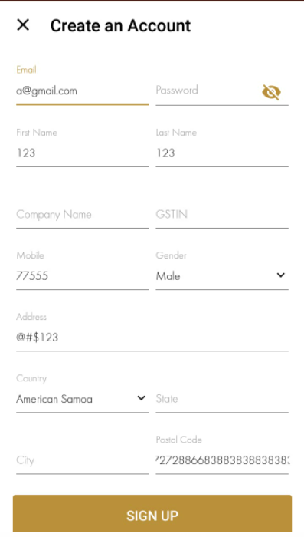

**Bug-ID 16**

**Module Name –** Sign up

**Bug description –** Mandatory field have asterisk sign (*).

**Expected result –** System should fire validation message for Mandatory fields.

**Bug image:**

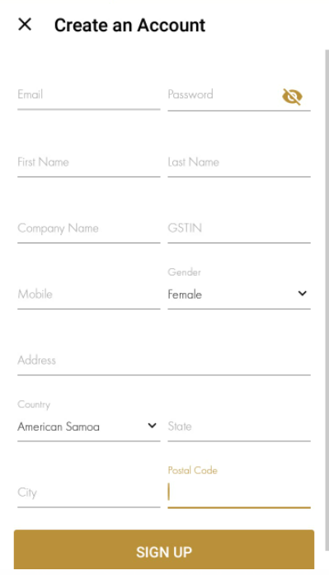

**Bug-ID 17**

**Module Name –** Sign up

**Bug description –** Accepts Invalid City Name.

**Test data –** City Name – “gvchgvhhvhv”

**Expected result –** System should fire validation message for Invalid City Name.

“Please enter valid City Name”

**Bug image:**

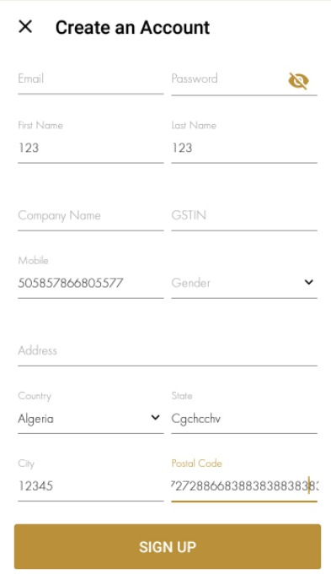

**Bug-ID 18**

**Module Name –** Sign up

**Bug description –** When user click on Sign up button and then click on back it will redirect on homepage instead of login page.

**Expected result –** System should redirect on Login page.

**Bug image:**

 